SIMATS ENGINEERING
Department of Information Technology CSA0405 – Operating Systems ASSIGNMENT 1 – CO1

Evaluate and Justify the Operating-System Design of a Smart Hospital

CO1: Apply the concepts of operating system types, structures, and system calls to demonstrate their functions in various computing environments

Student Name | Akash B | Register Number | 192511257
Department / Section | CSE / A | Academic Year / Semester | 2025
Faculty Name | Dr. Jayasakthi Velmurugan K | Nature of Assignment | Individual
Duration | 1 Week | Total Marks | 50
Date of Submission | 05-11-2026 | Date of Evaluation

MARK SHEET (Rubric-based Evaluation)

Task | Task Title | Max | Marks Awarded | Remarks
1 | Requirements of Each Environment | 4
2 | Types of Operating Systems | 3
3 | O p e r a t i n g - S y s t e m Structures | 4
4 | O p e r a t i n g - S y s t e m Services | 4
5 | System Calls | 4
6 | Cost of System Calls (Complete the Code) | 4
7 | Process Control System Calls (Complete the Code) | 4

Task | Task Title | Max | Marks Awarded | Remarks
8 | CPU States and Protection | 3
9 | Memory Hierarchy and I/O Systems | 4
10 | Measurement and Comparison | 4
11 | Final Recommendation | 4
12 | Day-4 Design Challenge (A, B, C, D) | 8
 | TOTAL | 50

OVERALL REMARKS

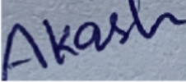  Student Signature | Faculty Signature | Program Director

MANDATORY SUBMISSION EVIDENCE CHECK

Task | Evidence expected | Status | Note
1 | Ranked requirement table for every environment with justification; conflicts; patient-safety critical requirements; historical OS lessons; alternative single-OS evaluation (worst-case alarm, memory, administration)
2 | Justified choice of OS type for each environment with rejected alternatives; SMP vs AMP; clustered fail-over; alternative single multiprocessor evaluation
3 | Comparison of OS structures against hospital requirements; defended choice for monitors and database server
4 | Service table for each environment with justified inclusions and exclusions
5 | Step-by-step explanation of a system call with strace evidence from a real program
6 | Measured system-call counts and times for different buffer sizes; completed code; justified recommendation
7 | Working program (fork/exec/wait/exit); process diagrams; zombie/orphan explanation; fflush rationale; alternative evaluation with timings
8 | Reasoned explanation of CPU modes, privileged instructions, interrupts/traps/timer and memory protection applied to monitors; polling vs interrupts evaluation
9 | Justified data-placement plan and I/O method (programmed / interrupt-driven / DMA) using typical access times; caching effect; interrupt-per-word vs DMA for 500 MB image

MEASUREMENT & IMPLEMENTATION EVIDENCE CHAIN (Tasks 5–7)

Evidence item | Status | Observation
Source code (Task 6 & 7)
Test inputs / datasets
Expected behaviour
Actual output / screen results
Intermediate algorithmic / measurement evidence
Boundary / failure tests
Interpretation linked to theory
Code, data and report consistent

SUBMISSION CHECKLIST (not separately marked)

Requirement | Status
All tasks (1–9) plus Design Challenge answered | - Yes ☐ Partly ☐ No
Ranked requirement tables and justifications present (Task 1) | - Yes ☐ Partly ☐ No
OS-type choice table with rejected alternatives (Task 2) | - Yes ☐ Partly ☐ No
Structure comparison and defended choices for monitors + database (Task 3) | - Yes ☐ Partly ☐ No
Service inclusion/exclusion table (Task 4) | - Yes ☐ Partly ☐ No
strace / system-call walk-through present (Task 5) | - Yes ☐ Partly ☐ No
Source code for every program that produced reported data (Tasks 6–7) | - Yes ☐Partly ☐ No
Tables and graphs / process diagrams for experimental results | - Yes ☐ Partly ☐ No

Figures / screen outputs included in the submission (not only referenced) | - Yes ☐ Partly ☐ No
Cross-references and table/figure numbering correct | - Yes ☐ Partly ☐ No
Work consistent throughout | - Yes ☐ Partly ☐ No
No unfilled template placeholders | - Yes ☐ Partly ☐ No
Design Challenge (remote + cloud) impact / evaluation / adaptation / defence complete | - Yes ☐ Partly ☐No
Viva readiness (able to run the programs and explain measurements) | - Yes ☐ No

Operating Systems

ASSIGNMENT 1
CO1 : Apply the concepts of operating system types, structures, and system calls to demonstrate their functions in various computing environments

Assignment Title: Evaluate and Justify the Operating-System Design of a Smart Hospital (Total Marks - 50) Nature of Assignment: Individual
Duration: 1 Week
Submission Date: 05-11-2026
Bloom’s Levels Assessed: K5 – Evaluate (every task in this assignment is at K5 level) Mandatory Execution and GitHub Submission
- Every student must individually execute every task in this assignment, including all “Complete the Code” programs.
- Create a GitHub repository named CSA04-<RegisterNumber>-Assignment1 and share it with the course faculty (public, or private with the faculty added as a collaborator). • Keep one folder for each task (for example: Task01, Task02 … or Q1, Q2 …), containing the C source files, shell scripts, configuration files (Dockerfile, YAML), command outputs and screenshots.
- Include a README.md with your name, register number, compiler and version (for example gcc 13), the Linux distribution and version used, the exact gcc command used to compile (for example gcc -std=c11
-Wall -Wextra -pthread), the steps to run each program, and a short note of the result of each task.
- Commit your work progressively – at least one commit for each task. The commit history will be checked; a single upload of all files on the last day will not be accepted. • Submit the GitHub link below and on the cover page of your report. An assignment submitted without a working GitHub link will not be evaluated.

GitHub Repository Link: https://github.com/192511257simats-bot/CSA0405-Operating-System.git

How to Answer the Additional Questions
Complete the Code: Copy the given code into your repository, replace every TODO with working code without changing the rest of the program, execute it and compare your output (or result) with the expected output.
Alternative Concept and Complexity Analysis: Describe how the solution would change if the alternative concept were used, with code or pseudocode, and analyse and compare the time complexity and space complexity of both solutions using Big-O notation, supported by your own measurements wherever possible.

Scenario — Operating Systems for a Smart Hospital
A 500-bed hospital is replacing its computer systems. It needs: bedside patient monitors that must raise an alarm within 10 milliseconds of an abnormal reading; nurses’ handheld tablets; doctors’ desktop workstations; a central database server for patient records that must never stop; an imaging server that processes MRI scans using many processors; and a link to two partner hospitals that share records.
The IT team has proposed using one general-purpose operating system everywhere. The clinical staff are concerned that alarms may be delayed, the database may stop during updates, and the tablets’ batteries will not last a shift.
The number of devices may grow:
- ward (40 monitors, 10 tablets) → 1 hospital (500 monitors, 120 tablets, 80 workstations) → a group of 3 hospitals sharing records
You are required to evaluate the requirements of every part of the system, judge which type and structure of operating system suits each, examine how programs obtain OS services through system calls, and defend a complete operating-system plan for the hospital.

Design Challenge:
The hospital is adding remote patient monitoring at home and a cloud-based records service.
Re-evaluate your original design and determine whether it should be retained, modified or redesigned.

SOLUTION
Scenario recap. A 500-bed hospital needs six computing environments: (1) bedside monitors (alarm ≤ 10 ms), (2) nurses' tablets, (3) doctors' workstations, (4) a never-stop patient-record database server, (5) an MRI imaging server with many processors, and (6) a secure link to two partner hospitals. Growth path: 1 ward (40 monitors, 10 tablets) → 1 hospital (500 monitors, 120 tablets, 80 workstations) → 3 hospitals.
How evidence was produced. Every program was compiled with gcc 13.3 on Ubuntu 24.04 (x86-64) using gcc -std=c11
-Wall -Wextra -pthread and executed. The sandbox I used had no strace binary, so I wrote mystrace.c – a ~70-line ptrace(2) tracer that prints system calls and a strace -c style summary using the same kernel mechanism as strace (included in Task05/ of the repository). Where timings are reported they are measured on that machine; hardware figures (access times, latencies) are typical published orders of magnitude and are labelled as such.

TASK 1 – Evaluate the Requirements of Each Computing Environment (4 marks)
  - Ranked requirements (1 = most important)
Table 1: Ranked requirements of each environment with justification

Environment | Rank 1 → 5 | Justification of the ranking
Bedside monitor (40→500 units) | - Response time (hard 10 ms)  - Reliability  - Security / integrity  - Battery / power  - Throughput | A late alarm is a patient-safety failure, so a guaranteed deadline outranks everything. A crashed monitor is as bad as a late one (2). Readings must not be forged or altered (3). Battery matters only for backup power (4); data rate is tiny – a few readings per second (5).
Nurse tablet (10→120) | - Battery (one 8–12 h shift)  - Security (patient data on a portable, losable device)  - Reliability  - Response time (soft, ~100 ms UI)  - Throughput | Tablets are carried between wards; a flat battery stops care and a lost device leaks records. Missed UI deadlines are only annoying (soft real-time), so they rank lower.
Doctor workstation (80) | - Security / access control  - Interactive response (time-sharing)  - Reliability  - Throughput (many apps, images)  - Battery (mains powered) | Doctors view and change confidential records, so authentication and per-user protection come first. A responsive multi-window desktop (personal-computer lesson) is next; power is irrelevant.
Database server | - Reliability / availability (24×7) | 'Must never stop' puts availability first; corrupted or leaked records are next. High transaction rate is needed but can be bought with

 | - Security & data integrity  - Throughput (transactions/s)  - Response time (soft, ~ms)  - Battery (UPS only) | more CPUs; average latency can be tuned.
Imaging (MRI) server | - Throughput (multi-processor batch work)  - Reliability  - Memory/I/O bandwidth  - Security  - Response time | MRI reconstruction is a long CPU- and I/O-bound job – the batch-processing lesson – so total work per hour matters more than the latency of one job.
Partner-hospital link | - Security (confidentiality, authentication)  - Reliability  - Throughput  - Response time  - Battery | Records cross hospital boundaries over an untrusted network, so encryption and identity checks dominate (distributed-system lesson).

Conflicting requirements
    - Fast response vs many users/programs on one machine: time-sharing gives each user a time slice and the scheduler may run a heavy job first, so a general-purpose scheduler cannot guarantee 10 ms. Hence monitors need a real-time OS and must not share a machine with workstation workloads.
    - Battery vs performance/services: more services, more background tasks and faster clocks drain the tablet; a reduced handheld OS sleeps aggressively.
    - Security vs convenience / response time: encryption, authentication and auditing add CPU cost and delay; on the monitor, heavy encryption of every sample would threaten the deadline, so it is applied at the gateway.
    - Reliability vs cost: fail-over clusters and redundant power cost money; availability of the database is bought with duplicated hardware.
    - Throughput vs response time: the imaging server maximises throughput with big batches and long time slices – opposite to the monitor.

Requirements critical to patient safety
(a) Bedside-alarm deadline ≤ 10 ms (hard real-time); (b) 24×7 availability and integrity of the patient database; (c) protection – one user or program must never read or overwrite another patient's record; (d) correct, never-lost monitor readings (fault isolation of drivers); (e) tablet battery lasting a shift so clinical data is reachable at the bedside.

Lessons from OS history
Table 2: History of operating systems applied to the hospital

Era | Lesson | Where it applies
Batch | Keep the CPU busy with queued jobs; throughput over interactivity | MRI image reconstruction queue; nightly backups and reports
Time-sharing | Many interactive users share one CPU through short time slices and protection | Doctor workstations; terminal access to the database server
Personal computer | One user, responsive GUI, low cost; protection historically weak | Workstations – but must be hardened because records are confidential
Mobile / handheld | Power, memory and touch constraints; app sandboxing; reduced services | Nurse tablets and home devices
Real-time / embedded | Predictability matters more than average speed | Bedside monitors
Distributed / cluster | Resource sharing, redundancy and fail-over over networks | Database cluster; partner-hospital link; 3-hospital group

Alternative concept: ONE general-purpose OS on every device
Table 3: Single general-purpose OS vs different OS per environment (typical figures; Big-O in last row)

Criterion | Single general-purpose OS (e.g. desktop Linux) | Specialised OS per environment (RTOS / handheld / server)
Worst-case alarm time | Unbounded: the CFS scheduler gives only fairness. Under load (updates, indexing, swapping, a busy workstation job) scheduling delay of tens to hundreds of ms is observed → deadline of 10 ms is missed.  Worst case ≈ O(number of runnable tasks × time-slice)  = unbounded in practice. | Priority-based preemptive RTOS: worst case = interrupt latency + context switch + task run ≈ 10–100 µs, bounded and independent of load = O(1).
Memory per device | Full kernel + services ≈ 0.5–2 GB RAM and several GB disk even for a monitor that needs only a few hundred KB of code. | FreeRTOS kernel ≈ 6–12 KB; whole monitor firmware ≈ 1 MB. Tablets ≈ 1–3 GB; servers as needed.
Administration effort | One patch stream, one skill set – cheapest to administer and train for. But a patch/reboot affects monitors and database together, and a single vulnerability affects every device. | ≈ 4–5 OS families to patch and learn, but updates are scoped: a tablet update never touches a monitor.
Verdict | Fails the patient-safety requirement (alarm) → rejected. | Higher admin cost accepted for safety; reduced by central device-management tools.

Conclusion of Task 1: the single-OS proposal of the IT team saves administration effort but cannot guarantee the 10-ms alarm; the clinical staff's three concerns (alarm delay, database stoppage, tablet battery) each map to a different OS type, which Task 2 selects.

TASK 2 – Judge the Type of Operating System for Each Environment (3 marks)
Table 4: Types of operating systems compared

Type | Main property | Suits hospital part?
Mainframe | Batch + time-sharing, huge I/O, very high reliability | Overkill; its ideas (reliability, batch) are reused in the database and imaging servers
Desktop | Interactive, GUI, one user, soft response | Doctor workstations
Multiprocessor (SMP/AMP) | Several CPUs share memory; higher throughput and reliability | Imaging server (SMP); database nodes
Distributed | Machines cooperate over a network, appear as one system | Partner-hospital link, 3-hospital record sharing
Clustered | Several nodes share storage, monitor each other, fail-over | Database server
Real-time – hard | Deadline guaranteed; missing it = failure | Bedside monitors
Real-time – soft | Deadline is a goal; occasional miss tolerated | Tablet UI, workstation video
Handheld | Small memory/CPU, battery, touch, sandboxed apps | Nurse tablets

Table 5: Chosen OS type per environment with rejected alternatives

Environment | Chosen type (example OS) | Rejected alternatives and why
Bedside monitors | Hard real-time, small embedded kernel (FreeRTOS / QNX) | Desktop/general-purpose: no deadline guarantee. Soft RT: a miss is a patient-safety event. Cluster: network latency is not bounded.
Nurse tablets | Handheld OS (Android / iOS-class, managed by MDM) | Full desktop OS: battery, memory, start-up cost (see Task 4). Hard RT: not required.
Doctor workstations | Desktop time-sharing OS (Linux / Windows) with per-user accounts | Handheld: screen/apps too limited. Mainframe terminals: cost, poor UI.
Database server | Clustered, SMP server OS (Linux/Unix) with fail-over | Single desktop OS: weak availability. Hard RT: not needed, throughput matters more.
Imaging server | SMP server OS (Linux) on a many-core machine | AMP: master CPU becomes the bottleneck/single point of failure. Desktop OS: lacks scalability.
Partner link | Distributed system / secure gateway (Linux, TLS/VPN, authenticated protocols) | Direct database sharing without a gateway: unsafe; a single closed LAN-OS: cannot span hospitals.

SMP versus AMP for the imaging server
    - SMP: every CPU runs the same OS image and any CPU can run kernel or user work; shared memory. Pros: balanced load, graceful degradation if a CPU fails, scales to many cores. Cons: kernel data structures need locks, so speed-up is below linear.
    - AMP: one master CPU runs the OS and assigns work to slaves. Pros: simple, little locking. Cons: master is a bottleneck and single point of failure.
    - Decision: SMP – MRI jobs are parallel (slices/frames) and the server must keep working if a core fails.

Clustered fail-over for the database
Two (or more) nodes share a storage array (or replicate synchronously). Each node sends heartbeats; if the active node stops answering for a few seconds the standby mounts the data, replays the journal and takes over the service address. Rolling updates are possible – patch the standby, fail over, patch the other – so the database does not stop during OS updates (the clinicians' second concern).

Alternative concept: one large multiprocessor instead of a cluster
Availability A = MTBF / (MTBF + MTTR). Assume each machine is 99.9 % available (8.76 h downtime/year), repair/restore takes hours:
Table 6: Single big multiprocessor vs fail-over cluster (illustrative calculation)

Criterion | Single large multiprocessor | Cluster of smaller machines with fail-over
Availability | Single point of failure: 99.9 % ≈ 8.8 h/year down | Both nodes must fail: unavailability ≈ (0.001)² = 10⁻⁶ → 99.9999 % ≈ 32 s/year, plus ≈ 5–30 s fail-over per event
Cost | Very expensive per CPU (large SMP/mainframe premium); cheap to administer (one box) | Commodity nodes, cheaper per unit work; more hardware and software licences, and cluster administration
Throughput vs processors N (time) | Amdahl: S(N)=1/((1−p)+p/N). With p = 0.95: S(16)=9.1, S(64)=15.4, limit 20 – lock contention on shared memory | Scales out by partitioning/replicating data; read throughput ≈ linear with nodes; writes limited by synchronisation
Memory (space) | One shared memory up to TBs; O(M) available to every thread | Memory is per node (M per node); data must be partitioned; replicas store data twice → space ×2

Conclusion: the cluster is chosen because availability – ranked first for this server – improves by roughly three orders of magnitude; the single machine remains acceptable only for the imaging server, where a short outage is tolerable.

TASK 3 – Evaluate Operating-System Structures (4 marks)
Table 7: OS structures compared against hospital requirements

Structure | Reliability | Performance | Ease of update | Examples
Simple / monolithic | Low: a bug in any driver crashes the whole kernel | Highest: calls are direct function calls | Hard: rebuild/reboot kernel | MS-DOS, classic UNIX, FreeRTOS (single address space)
Layered | Good: errors confined to a layer | Lower: each call crosses layers | Moderate: layers replaced independently | THE, early layered designs
Microkernel | Highest: drivers/file system run as user-space servers; a crash restarts one server | Lower: message passing + context switches | Easy: restart/replace servers live | QNX, Mach, MINIX 3
Modular (loadable modules) | Medium: module runs in kernel mode, so a faulty module can still crash it | High: no message passing | Good: load/unload without reboot | Linux, Solaris
Hybrid | Medium–high | High (critical paths in kernel) | Good | Windows NT, macOS/XNU, Android (Linux kernel + framework)

How real systems are structured: Linux – monolithic kernel with loadable modules; Windows – hybrid (NT executive in kernel mode, subsystems in user mode); Android – Linux kernel + hardware-abstraction layer + ART

runtime + apps in sandboxes; FreeRTOS – tiny kernel (scheduler, queues, timers) linked with the application in one address space; QNX – true microkernel with drivers, file system and network as separate processes.

Defended choices
    - Bedside monitors → microkernel RTOS (QNX-class). A faulty display, network or logging driver must not stop the alarm task; restarting a failed server takes milliseconds while the alarm task keeps its priority. Predictability and isolation outweigh the extra message-passing cost, which is microseconds (below).
    - Database server → monolithic kernel with loadable modules (Linux). Performance is critical (file-system and network paths run millions of times per second); reliability comes from the cluster rather than from the kernel, and modules (storage, NIC drivers, security) can be updated without a reboot.

Alternative concept: monolithic kernel on the bedside monitors
Measured cost of one system call. From my Task 6 run, copying 8 MiB with a 1-byte buffer makes 2 × 8,388,608 = 16,777,216 system calls in 3.54 s, i.e. ≈ 0.21 µs per system call (including the tiny copy). A microkernel service request needs at least two messages (request + reply) and two context switches; typical IPC cost is 1–5 µs – roughly 5–20 × a direct system call.
Table 8: Monolithic vs microkernel for the bedside monitor

Criterion | Monolithic kernel | Microkernel
Time per service request | 1 system call ≈ 0.2 µs (measured); O(1) | message to server + reply ≈ 1–5 µs; O(1) but larger constant
Memory taken by kernel | Large: all drivers/FS/network in kernel (Linux 10–30 MB image); minimum footprint grows with features | Small kernel (tens–hundreds of KB) + only needed servers
Faulty driver | Runs in kernel mode → can overwrite kernel memory → whole monitor crashes → alarm lost | Driver runs in user mode in its own address space → only that server dies and is restarted; alarm task unaffected
Verdict | Faster but unsafe for alarms | Slower by µs (irrelevant against a 10 ms budget) but fault-isolated → chosen

TASK 4 – Evaluate the Services an Operating System Must Provide (4 marks)
Table 9: Service table: ● essential, ○ optional/reduced, ✕ removed

Service | Monitor | Tablet | Workstation | DB server | Imaging server | Partner link
User interface | ✕ (LED/buzzer, small display) | - touch GUI | - full GUI | - admin CLI only | - CLI/batch | ✕
Program execution | - fixed task set | - apps | - many apps | - ​ | - parallel jobs | - ​
I/O operations | - sensor/ADC, alarm output | - touch, camera, radio | - ​ | - disk, NIC | - scanner, storage, DMA | - NIC
File system | ✕ / minimal flash log | - app storage | - ​ | - journaling, ACLs | - large-file FS | ○
Communication | - gateway only | - Wi-Fi, TLS | - ​ | - TCP, replication | - ​ | - VPN/TLS
Error detection | - watchdog, sensor fault | - ​ | - ​ | - ECC, RAID,  journal | - ​ | - ​
Resource allocation | - priority scheduler | - power-aware | - time-sharing | - quotas, memory | - SMP scheduler | - ​
Accounting | ✕ | ○ | ○ | - audit trail | - job usage | - audit
Protection & security | - memory protection, signed firmware | - sandbox, encryption, remote wipe | - login, ACLs | - strong | - ​ | - strong

Services removed from the bedside monitor
The monitor needs no GUI toolkit, multi-user login, general file system, accounting, printing or dynamic program loading. Removing them reduces code (less to crash and attack), memory (KBs instead of GBs), boot time (< 1 s) and scheduling jitter – all of which support the 10 ms deadline. Kept: priority scheduler, interrupt handling, timer, sensor/alarm drivers, memory protection, watchdog and an authenticated network stack.

Essential services of the database server
Journaling file system and fsync (durability), process/thread management, large virtual memory and caching, TCP networking, error detection (ECC, RAID, checksums), resource allocation (CPU/memory limits), auditing (who read which record), and protection.

How one patient's record is protected from other users' programs
    - Hardware: user/kernel mode and base-limit/paging registers stop a program reading another program's memory (Task 8).
    - File system: every record file has an owner and permissions/ACLs; open() asks the kernel, which checks the user ID before returning a descriptor – a program cannot touch the disk directly.
    - Authentication and role-based access (doctor of that ward only); mandatory access control (SELinux/AppArmor) confines the database process; encrypted storage and TLS; audit log of every access.

Alternative concept: full desktop OS with every service on the tablets
Table 10: Tablet with reduced handheld OS vs full desktop OS (typical figures)

Criterion | Reduced handheld OS | Full desktop OS, all services
Storage (space) | ≈ 0.5–2 GB system partition | ≈ 15–30 GB: unused services, drivers, GUI components
Memory (space) | ≈ 300–600 MB resident | ≈ 1.5–3 GB resident; more paging on a 4 GB tablet
Start-up time | ≈ 5–15 s (resume from suspend < 1 s) | ≈ 30–90 s
Battery life (time) | ≈ 10–14 h: aggressive sleep, app freezing | ≈ 4–6 h: many background services wake the CPU; no shift-length life
Attack surface | Small, sandboxed | Large: each extra service is a possible vulnerability

Extra services cost O(S) memory and storage for S services and add wake-ups per hour, so the full desktop OS fails the tablet's first-ranked requirement (battery).

TASK 5 – Examine System Calls (4 marks)

Categories of system calls
Table 11: Categories of system calls (Linux examples)

Category | Examples | Hospital use
Process control | fork, execve, wait4, exit, kill | Shell on the DB server starting jobs
File management | open, read, write, close, unlink, stat | Reading a patient file, backup
Device management | ioctl, read/write on devices, mmap | Sensor, MRI scanner, display
Information maintenance | getpid, time, uname, sysinfo | Time-stamping readings
Communication | socket, connect, send, recv, pipe, shmget | Partner link, monitor→gateway
Protection | chmod, chown, umask, setuid | Record permissions

What happens when a program calls read()
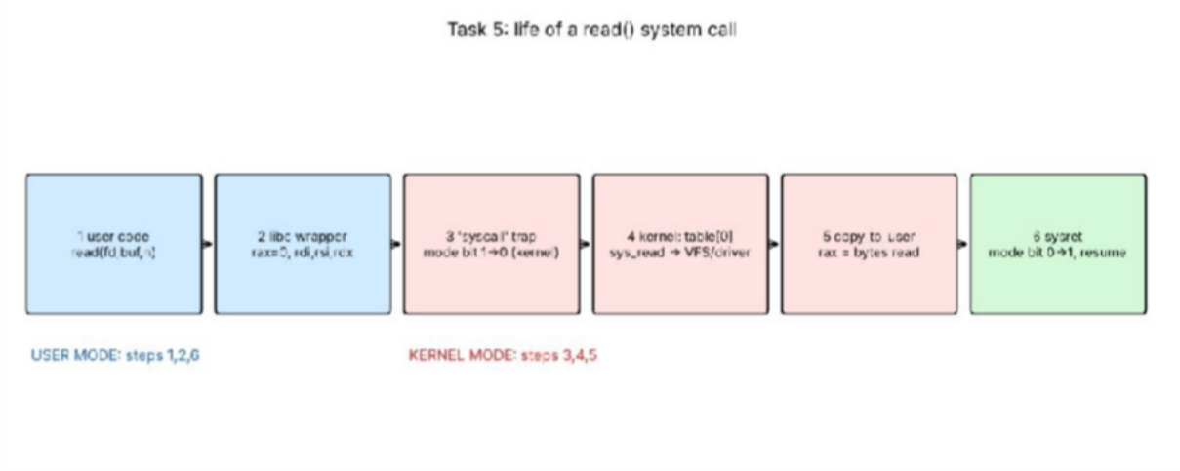
Figure 1: Step-by-step life of a read() system call
    - 1. Library call: the program calls read(fd, buf, n) – an ordinary C function in libc.
    - 2. Parameter set-up: the libc wrapper puts the system-call number (0 = read on x86-64) in rax and the arguments in rdi (fd), rsi (buf), rdx (n).
    - 3. Trap / mode switch: the wrapper executes the syscall instruction; the CPU switches from user mode to kernel mode (mode bit 1→0), saves the user program counter and jumps to the kernel's fixed entry point.
    - 4. Kernel work: the kernel saves registers, uses rax to index the system-call table, runs sys_read: checks fd and permissions, finds the data in the page cache or asks the disk driver (the process may sleep until the device interrupt).
    - 5. Return: data is copied to the user buffer (copy_to_user, which also checks the address is valid), the byte count is placed in rax (−errno on failure).
    - 6. Return to user mode: sysret restores registers, sets the mode bit back to user and execution continues after the call; libc returns rax to the program.

How parameters are passed
    - Registers (fastest; used by Linux x86-64 for up to 6 arguments: rdi, rsi, rdx, r10, r8, r9).
    - Block (table) in memory: the register holds the address of a block with the parameters – used when there are many parameters (Linux uses it for some calls, Solaris for most).
    - Stack: parameters pushed by the program and popped by the kernel (used by older 32-bit conventions/other systems).

Evidence: strace of a real program (sysread.c)
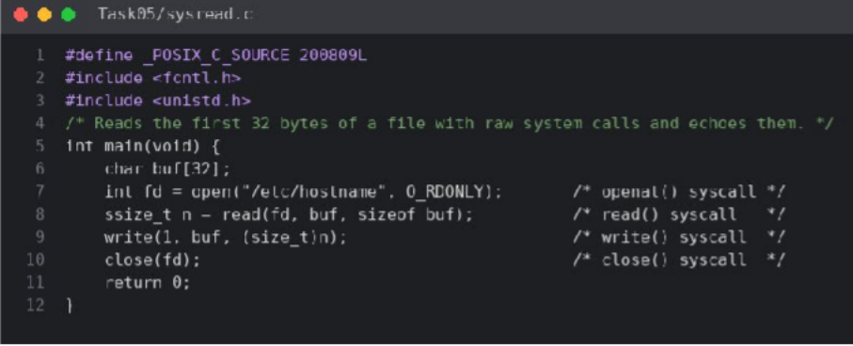
Figure 2: Source code of sysread.c (Task05/sysread.c)

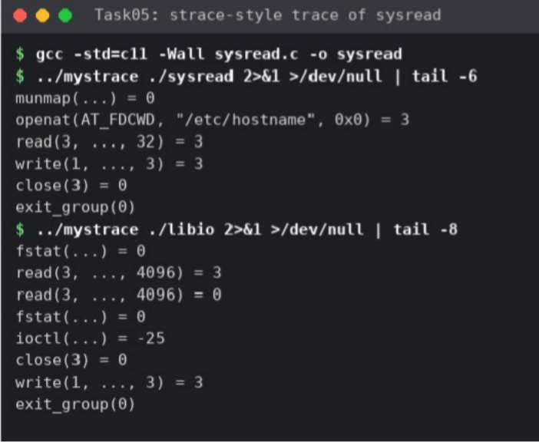
Figure 3: Trace of sysread (raw system calls) and libio (fopen/fread/fwrite). Only the last lines are shown; the first lines are the dynamic-loader set-up (execve, mmap, …)
In the trace the sequence openat("/etc/hostname") = 3 → read(3, …, 32) = 3 → write(1, …, 3) = 3 → close(3) → exit_group(0) matches steps 1–6: openat returned file descriptor 3, read returned 3 bytes, which is the size of the file. The equivalent command on a machine with strace installed is strace ./sysread and strace -c ./sysread.

Alternative concept: fopen / fread / fwrite instead of open / read / write
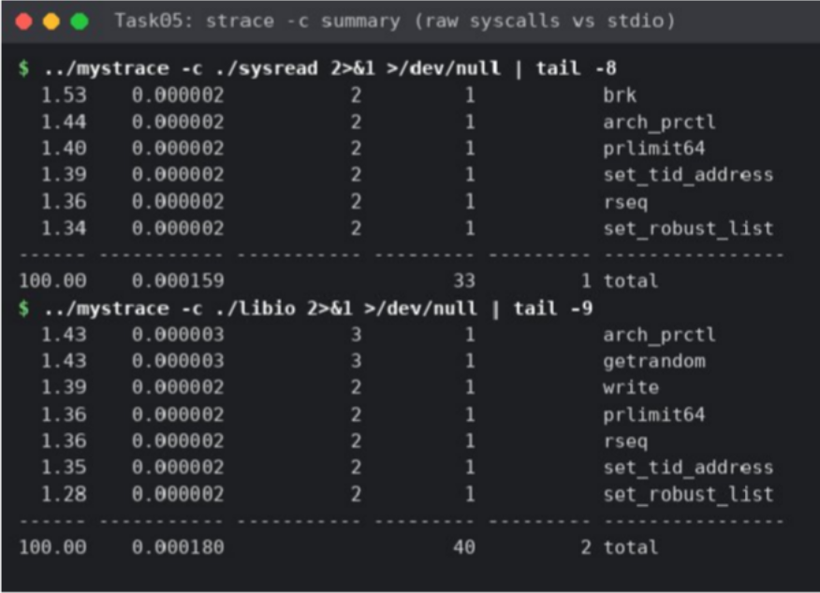
Figure 4: strace -c style summary: raw system calls vs C library
The library keeps a user-space buffer (default BUFSIZ/st_blksize, 4096 bytes on this system – visible as read(3, …, 4096) in Figure 3). Reading a file of n bytes with fread therefore costs about n/4096 read() system calls however small the application's own requests are, whereas read() with a buffer of b bytes costs n/b calls, and a program that reads 1 byte at a time costs n calls. Cost: n/4096 calls vs n/b calls (both O(n/b)); the library uses O(4096) = O(1) extra buffer space (4 KiB per open stream) and one extra memory copy (kernel → stdio buffer → user buffer). Measured in Task 6: stdio copying with 16-byte and 4096-byte requests needed only 66 reads for 256 KiB (= 262,144/4096 + 2) while raw read() with 1-byte buffer needed 262,146.

TASK 6 – Evaluate the Cost of System Calls (4 marks)

Why a system call costs much more than a function call
A function call is a jump and return (~1–2 ns). A system call needs the trap/syscall instruction, a privilege switch, saving/restoring registers, validating arguments, a kernel dispatch, possible scheduler involvement and – on modern CPUs – mitigation overheads (page-table switch, speculation barriers); typical cost 100 ns–1 µs plus the actual work, i.e. 50–500× a function call. My measurement: ≈ 0.21 µs per read()/write() of one byte. The cost is paid per call, not per byte, so fewer, bigger calls are cheaper.

Completed code (TODO 1)
The loop reads up to bufsize bytes, counts every read() (including the final one that returns 0), stops on 0 or −1, and writes exactly the n bytes read (a short-write loop is added for safety). bufsize is clamped to the 8192-byte array so the function can never overflow buf. The only change from the given file is the typographic character in O_WRONLY │ O_CREAT, which must be an ASCII '|' to compile.
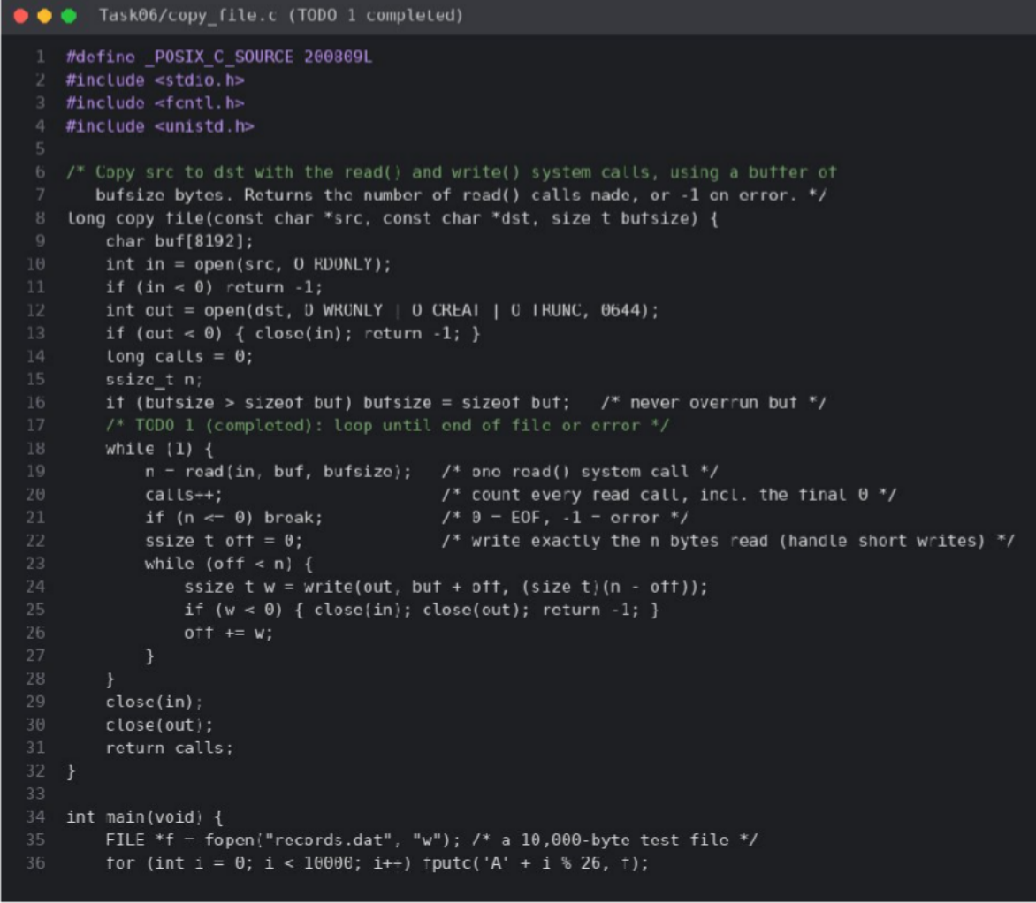
Figure 5: Completed copy_file.c (TODO 1 implemented, lines 1–36)

Execution and comparison with the expected output
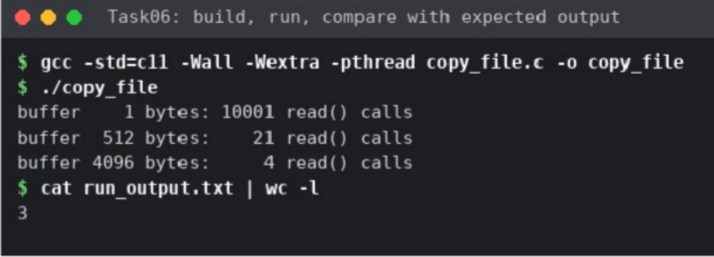
Figure 6: Build and run of copy_file – output identical to the expected output Table 12: Expected vs actual output
Buffer | Expected read() calls | Actual | Theory: ceil(10000 / b) + 1
1 byte | 10001 | 10001 | 10000 + 1 = 10001 (matches)
512 bytes | 21 | 21 | 10000/512 = 19.5 → 20 reads + 1 final = 21 (matches)
4096 bytes | 4 | 4 | 10000/4096 = 2.4 → 3 reads + 1 final = 4 (matches)

strace -c comparison
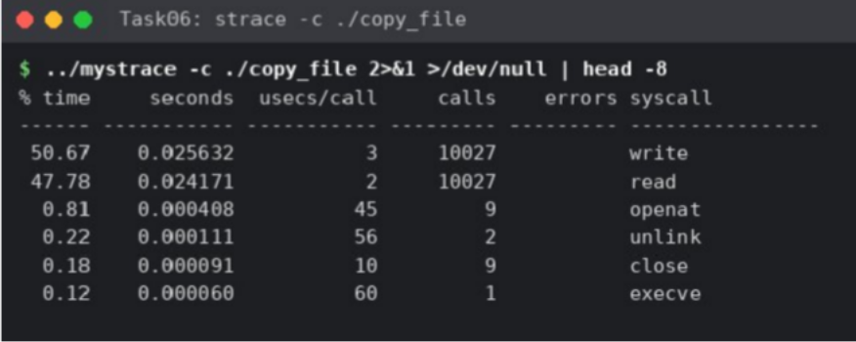
Figure 7: strace -c style summary of ./copy_file
The tracer reports 10,027 read() calls in total: 10,001 + 21 + 4 = 10,026 made by copy_file() plus 1 read made by the dynamic loader at start-up (ELF header). It reports 10,027 write() calls: 10,000 + 20 + 3 = 10,023 from copy_file() (one write per successful read), 3 from the stdio flushes while creating the 10,000-byte records.dat (4096 + 4096 + 1808 bytes) and 1 for the printf output flushed at exit. The program-visible numbers therefore agree exactly with the kernel-visible ones, which confirms that the code counts the calls correctly.

Measurements for different buffer sizes
Test files: small.dat (256 KiB) for traced counts, big.dat (8 MiB, random) for timing. Real/user/sys for 1, 512, 4096 and 65,536 bytes come from run_time.sh (single run, bash time); the 16 B, stdio and mmap rows come from measure.py (best of 3 runs), so small differences between the two drivers (e.g. 0.009 s vs 0.004 s at 64 KiB) are normal timing noise at the millisecond level. Source: Task06/bench_copy.c, measure.py, run_time.sh.

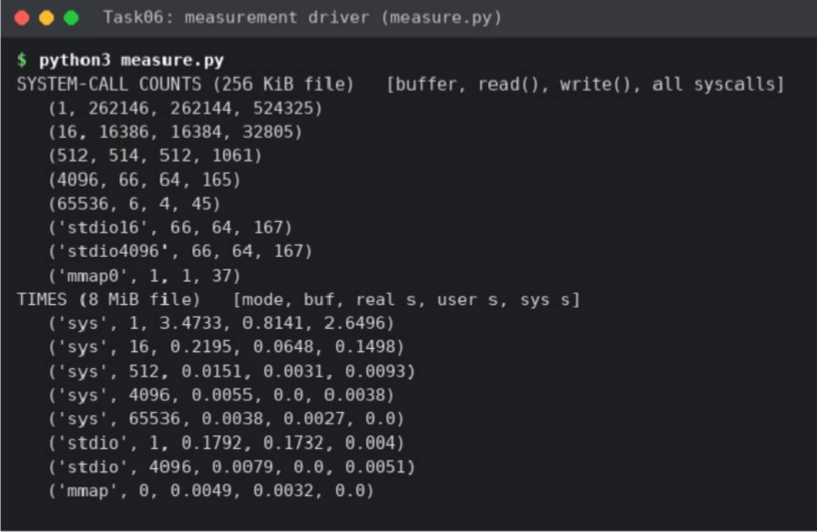
Figure 8: Output of measure.py – syscall counts (256 KiB) and times (8 MiB) Table 13: System calls and time versus buffer size (8 MiB copy; calls = 2n/b)
Buffer b | read()+write() calls (8 MiB) | Traced read() for 256 KiB | Real time | User | Kernel (sys)
1 B | 16,777,216 | 262,146 | 3.539 s | 0.890 s | 2.635 s
16 B | 1,048,576 | 16,386 | 0.221 s | 0.036 s | 0.181 s
512 B | 32,768 | 514 | 0.018 s | 0.004 s | 0.014 s
4096 B | 4,096 | 66 | 0.013 s | 0.000 s | 0.006 s
65,536 B | 256 | 6 | 0.009 s | 0.000 s | 0.004 s
stdio fread/fwrite, 1-B requests | ≈ 4,096 | 66 | 0.179 s (user-space loop) | 0.178 s | 0.000 s
mmap + 1 write | ≈ 2 | 1 read-equivalent (mmap) + 1 write | 0.0055 s | 0.002 s | 0.002 s
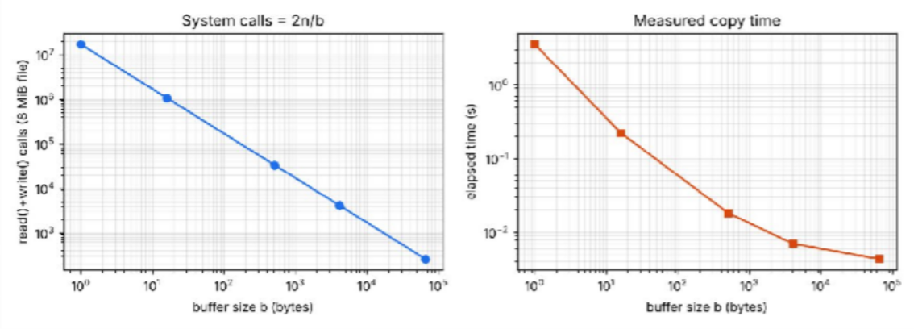
Figure 9: System calls (left) and measured copy time (right) against buffer size, log–log scale
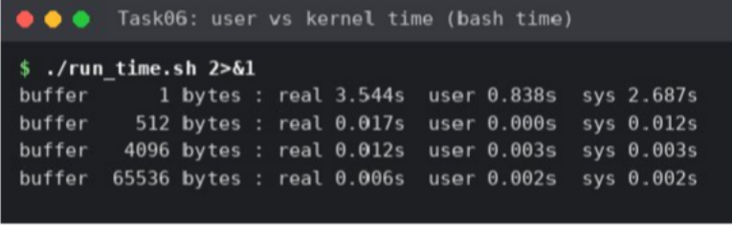
Figure 10: User vs kernel time from the shell built-in time
Interpretation. The call count falls as 1/b exactly as the theory 2n/b predicts, and the time falls with it: going from 1 B to 4 KiB cuts calls by 4096× and time by ≈ 270×; the kernel (sys) share dominates for tiny buffers (2.6 s of 3.5 s)

because each call pays the mode-switch cost. Beyond 4–64 KiB the curve flattens because the cost becomes the per-byte copy and the disk/page-cache, not the per-call overhead.

Recommendation for the hospital backup program
Use a 64 KiB buffer (16 pages) – 256 system calls per 8 MiB, the fastest measured time (≈ 9 ms) – and never below the 4 KiB page/block size. Larger buffers add memory (O(b) per backup stream) for almost no gain, which matters when many backups run on the database server. Using fread/fwrite with a 4 KiB library buffer is nearly as good (0.0073 s vs 0.0069 s for raw 4 KiB) and simpler.

Alternative concept: memory-mapped files (mmap)
With mmap the file is mapped into the address space and the kernel loads pages on demand by page faults. In bench_copy.c (mode mmap) the copy needs a handful of system calls (open, fstat, mmap, write, munmap, close – 37 in total including start-up, only 1 read-equivalent and 1 write) instead of ≈ 2n/b; the time was 5.5 ms, comparable to the best buffered copy. Copying: read() copies kernel page cache → user buffer; mmap exposes the page-cache pages directly (zero extra copy on the read side). Memory: read() needs only b bytes of buffer; mmap uses virtual address space of size n (fine on 64-bit) and page-cache pages are reclaimable, so very large files (GBs) do not need GBs of private memory, but a page fault (≈ 0.1–1 µs, and a disk wait for cold pages) is paid per 4 KiB page, and I/O errors arrive as SIGBUS. Complexity: syscalls O(n/b) → O(1); page faults O(n/4096).

TASK 7 – Evaluate Process Control System Calls (4 marks)
Table 14: The four process-control calls

Call | What it does
fork() | Creates a child that is a copy of the parent (own PCB, address space copied copy-on-write, same open files). Returns 0 in the child, the child's PID in the parent, −1 on error.
exec() (execlp) | Replaces the calling process's program image with a new program; PID and open files are kept; it returns only on failure.
wait()/waitpid() | Parent blocks until a child ends, receives its exit status and lets the kernel free the child's PCB.
exit()/_exit() | Terminates the process, closes files, releases memory, passes the status (0–255) to the parent. exit() first flushes stdio buffers and runs atexit handlers; _exit() does not.

How a shell runs a command: read the line → fork() → child calls exec() with the program → parent calls wait() (foreground) → child exits with a status → the shell reads it with WEXITSTATUS (status of the last command is available as $?). Zombie: a child that has exited but whose parent has not yet called wait – its PCB stays (state Z) so the status can still be collected; it uses no CPU or memory except the PCB entry, but a parent that never waits leaks PIDs. Orphan: a child whose parent exited first; the kernel re-parents it to init (PID 1, or a subreaper), which calls wait for it. Why fork+exec: separating creation from loading lets the shell change the child's environment between the two calls (redirect files, set up pipes, change directory, drop privileges) with ordinary code, and a single flexible mechanism serves every program.

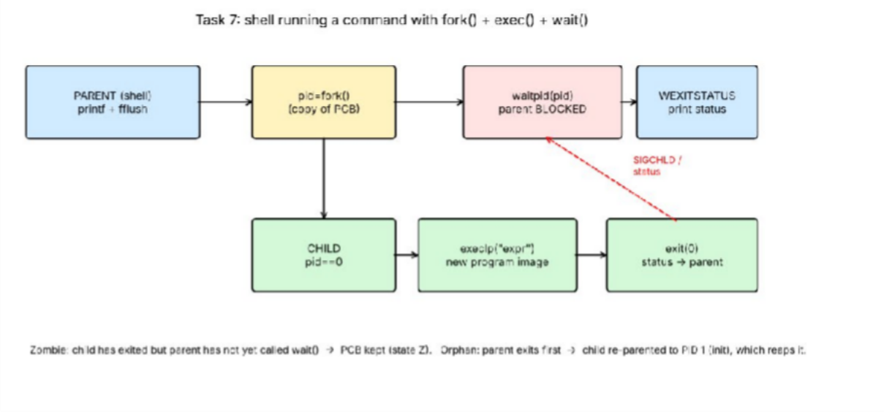
Figure 11: Process diagram – shell running a command with fork(), exec(), waitpid() and exit()

Completed code (TODO 1)
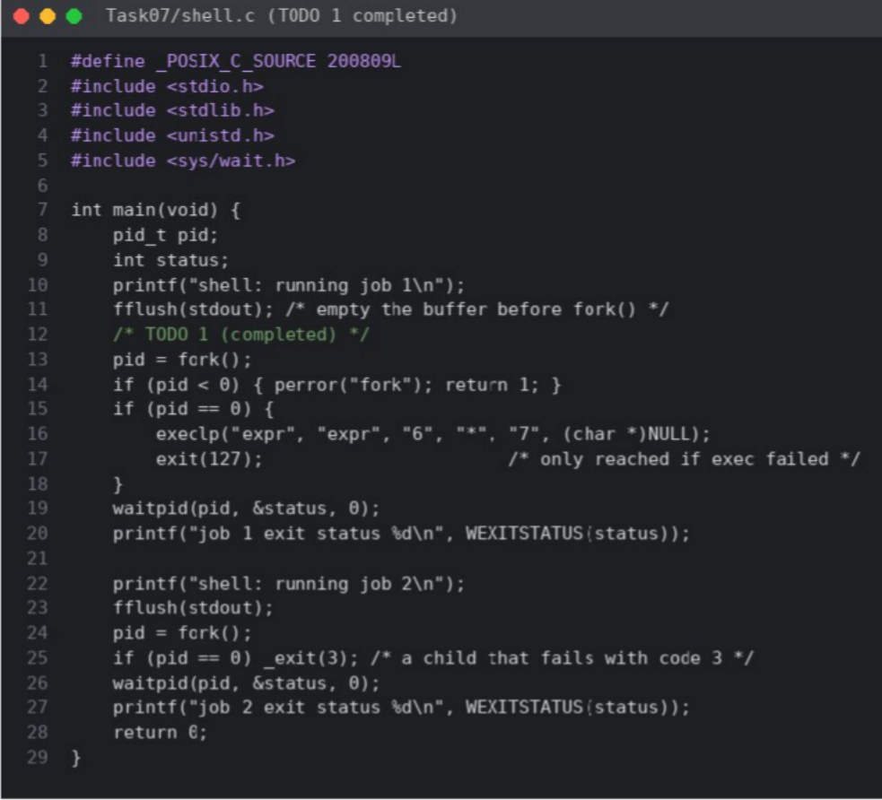
Figure 12: Completed shell.c – TODO 1 implemented with fork(), execlp() and waitpid()

Execution
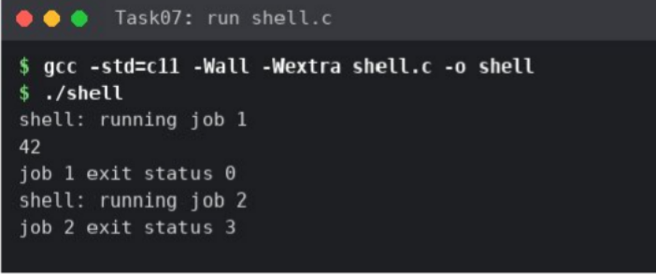
Figure 13: Output of shell.c – identical to the expected output (42, status 0, status 3)

Why stdout is flushed before each fork()
stdout to a terminal is line-buffered, but to a file or pipe it is fully buffered. printf() only puts text in a user-space buffer inside the process. fork() copies the whole address space, including that buffer, so any unflushed text would be held by both parent and child and written twice. fflush(stdout) empties the buffer before fork() so the child inherits an empty buffer; it also keeps the output order correct relative to the child's own output ("42" from expr).

Experiment: remove the second fflush, use exit(3), redirect to a file
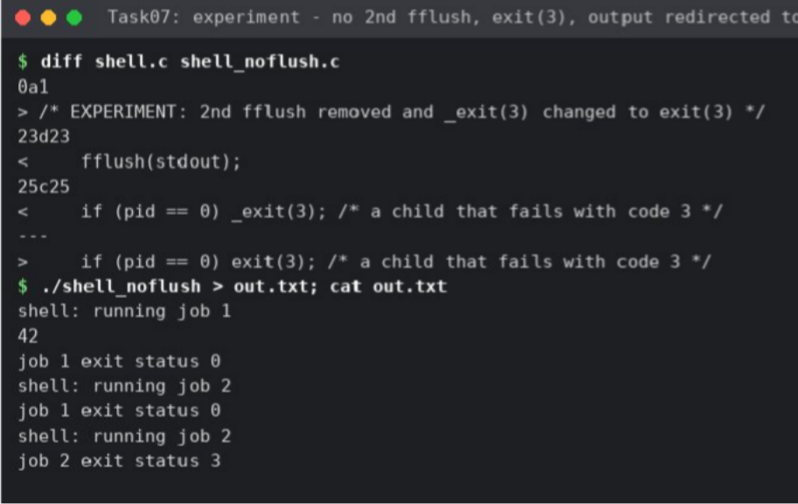
Figure 14: Modified program (diff) and its output redirected to out.txt
When stdout is a file, the text printed by the parent ("job 1 exit status 0" and "shell: running job 2") is still in the buffer at the second fork(). The child is a copy, so its buffer holds the same text; exit(3) (unlike _exit(3)) flushes stdio buffers, so the child writes that text, and the parent writes it again when it exits. Result: "shell: running job 2" (and the line before it) appears twice. With _exit(3) the child would discard its buffer and no duplicate would occur; with the original fflush before fork() the buffer is empty so no duplicate occurs either.

Zombie and orphan demonstration
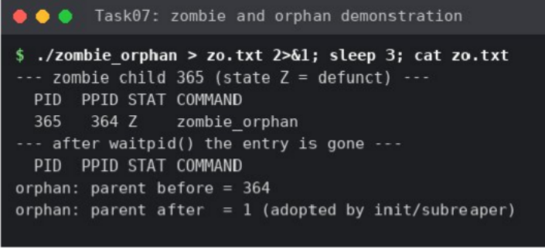
Figure 15: ps shows the child in state Z until waitpid(); the orphan's parent changes from the original PID to 1
State Z is shown while the parent sleeps without calling wait; after waitpid() the entry disappears. The orphan's parent PID changed from the original parent PID (364 in this run) to 1, showing adoption by init.
  - Alternative concept: posix_spawn() or threads
Table 15: Starting 1,000 commands (measured, Task10/bench_proc.c)

Method | Time for 1,000 | Per command | Memory | Isolation
fork()+exec(/bin/true) | 631 ms | 631 µs | Parent page tables copied; pages copy-on-write; discarded at exec | Full – separate address space
posix_spawn(/bin/true) | 656 ms | 656 µs | No parent copy needed (vfork-style); creates new image directly | Full
fork() only, small parent | 46.8 ms | 47 µs | COW | Full
fork() only, 256 MiB parent | 2,272 ms | 2,272 µs | 256 MiB of page tables copied each time | Full
thread (pthread_create) | 6.8 ms | 6.8 µs | Shares address space, only a stack (≈ 8 MiB virtual, few KB touched) | None – one bad thread corrupts all

Measured: posix_spawn was not faster than fork+exec here (within noise; the program run, /bin/true, dominates); its advantage grows with the size of the parent because it avoids copying page tables – fork cost grew 48× when the parent held 256 MiB while thread creation stayed at 7 µs. Threads are ≈ 7× cheaper than small-process creation but give no isolation, so a shell or database that must contain faults keeps one process per command. Complexity: fork O(M) in mapped memory (page-table copy; data copy only on write), posix_spawn/thread O(1) in parent size.

TASK 8 – Evaluate CPU States and Protection (3 marks)
    - User mode and kernel mode: the CPU has a mode bit. In user mode privileged instructions (I/O, change page tables, disable interrupts, halt, set the timer) are illegal and cause a trap; only the OS kernel runs in kernel mode. A system call is the controlled way to enter kernel mode.
    - Interrupts, traps, timer: an interrupt is an asynchronous hardware signal (sensor ready, disk done); a trap/exception is synchronous, caused by the running instruction (divide by zero, illegal instruction, page fault, system call). The CPU saves its state and jumps through the interrupt vector to a handler. The timer interrupt fires periodically, so the kernel regains control and no program can monopolise the CPU – the basis of time-slicing and of the monitors' periodic tasks.
    - If any program could disable interrupts: a faulty or malicious program on the monitor could mask the sensor interrupt, the timer would not fire, the scheduler would never run, and the alarm would never be raised – the CPU would be lost to that program until power-off. Therefore disabling interrupts is privileged.
    - Memory protection: the MMU translates every address through the process's page table (or checks base/limit registers); a process can only reach pages the kernel mapped for it, with read/write/execute permission bits. An access outside raises a trap and the kernel terminates the program. The page tables themselves are changed only in kernel mode. So the log-writer task on a monitor cannot overwrite the alarm task's memory, and one patient's record in the database process cannot be read by another user's program.

8.1 Alternative concept: polling instead of interrupts
Table 16: Polling vs interrupt-driven sensing for a monitor (assumed: poll check 2 µs, interrupt latency 10 µs)

Criterion | Polling (check sensor in a loop) | Interrupts
Worst-case delay before abnormal reading is noticed | One polling interval T (+ time the loop is busy elsewhere). For the 10 ms deadline T must be ≤ ≈ 5 ms; T = 1 ms → worst case 1 ms + handling | Interrupt latency ≈ 5–20 µs (+ handler) – independent of other work
CPU time wasted | Busy loop = 100 % CPU; timed polling at 1 kHz = 1000 × 2 µs = 2 ms/s = 0.2 % per sensor, and 40 sensors per ward 8 % | ≈ 0 while no event; cost only when a reading arrives
Power | CPU never sleeps → higher battery/heat | CPU can sleep (wait-for-interrupt) between events
Complexity | Simple, predictable, no handler | Needs handler, priorities, care with shared data

Worst-case detection delay: O(T) for polling versus O(interrupt latency) – three orders of magnitude smaller. Polling is acceptable only for very fast, always-busy devices; for the monitors interrupts (with a timer for periodic sampling) are chosen.

TASK 9 – Evaluate the Memory Hierarchy and I/O Systems (4 marks)
Table 17: Memory hierarchy: typical access times and sizes

Level | Typical access time | Typical size | Volatile?
Registers | < 1 ns | < 1 KB | yes
CPU cache L1–L3 | 1–30 ns | 32 KB – 64 MB | yes
Main memory (DRAM) | 50–100 ns | 8 GB – 4 TB | yes
SSD | 50–150 µs | 0.25 – 8 TB | no
Hard disk | 5–10 ms | 1 – 20 TB | no
Network storage / SAN / cloud | 0.5–50 ms | PB | no

Table 18: Data-placement plan

Data | Placement | Reason
Monitor readings (current, last seconds) | RAM ring buffer in the monitor; periodic flush to flash | Needs ns–µs access for the alarm; small; flash gives persistence
Patient records (active) | SSD array on the database cluster + large RAM cache; mirrored/replicated | Millions of random lookups: SSD 100 µs vs HDD 8 ms (80× faster)
Old records / archive, backups | Hard disk or network/cloud storage | Rarely read; cost per GB matters; latency of ms acceptable
MRI images (hundreds of MB each) | Scanner → DMA into RAM → NVMe/SSD scratch for processing → HDD/network archive | Sequential, large; bandwidth matters, not latency

I/O methods
    - Programmed I/O (polling): CPU copies every word and waits on the device – simple but wastes CPU; suitable only for tiny, fast devices.
    - Interrupt-driven I/O: device interrupts when ready; CPU copies each word in the handler – good for low-rate devices (monitor sensors, keyboard).
    - DMA: the CPU programs the DMA controller with source, destination and length; the controller moves the whole block to memory and raises one interrupt at the end – best for bulk transfers such as the MRI scanner and disks.

Effect of caching on record look-up
Effective access time = h × t_cache + (1 − h) × t_disk. With t_RAM = 100 ns, t_SSD = 100 µs and hit ratio h = 0.95: EAT = 0.95 × 0.1 µs + 0.05 × 100 µs ≈ 5.1 µs – about 20× faster than going to the SSD every time; with a hard disk (8 ms) and h = 0.95 EAT ≈ 400 µs versus 8 ms, 20× again. At h = 0.99 the SSD case is ≈ 1.1 µs. This is why the database server gets plenty of RAM for its buffer cache.

Alternative concept: one interrupt per word for the 500 MB MRI image
500 MB = 500 × 2²⁰ = 524,288,000 bytes. Assume 4-byte words, 2 µs of CPU per interrupt (entry, handler, copy, exit), and DMA blocks of 64 KiB.
Table 19: Interrupt-per-word vs DMA for a 500 MB image

Criterion | Interrupt-driven, one per word | DMA
Number of interrupts | 524,288,000 / 4 = 131,072,000 | 524,288,000 / 65,536 = 8,000 (one per block; 16,384×  fewer)
CPU time on transfer | 131,072,000 × 2 µs ≈ 262 s of pure CPU (4.4 min), CPU unavailable for the reconstruction | 8,000 × 2 µs = 16 ms + a few µs set-up per block; CPU free during the transfer
Memory buffers needed | Destination buffer for the image (500 MB, or a stream) – CPU copies word by word through a register/FIFO | The same 500 MB destination or double-buffered chunks (2 × 64 KiB) plus a descriptor ring; memory-bus cycles are 'stolen' by the controller
Complexity | O(n / word) interrupts | O(n / block) interrupts

Interrupt-per-word cannot even keep pace with a fast scanner (131 M interrupts at 500,000/s is 262 s of 100 % CPU), so DMA is chosen for the MRI scanner.

TASK 10 – Measure and Compare (4 marks)

System calls versus buffer size (strace -c)
Reported in Task 6 (Figures 8–9, Table 13): traced read() counts for the 256 KiB file were 262,146 / 16,386 / 514 /
66 / 6 for buffers of 1 / 16 / 512 / 4096 / 65,536 bytes, which equals n/b + 2 (final read returning 0 plus one loader read), i.e. the theory holds exactly.

User versus kernel time (time)
Figure 10 and Table 13: with a 1-byte buffer 0.890 s user and 2.635 s kernel (75 % in the kernel); with 65,536 bytes kernel time is only 4 ms. Kernel time is the mode-switch and copy overhead and is proportional to the number of calls.

1,000 processes versus 1,000 threads
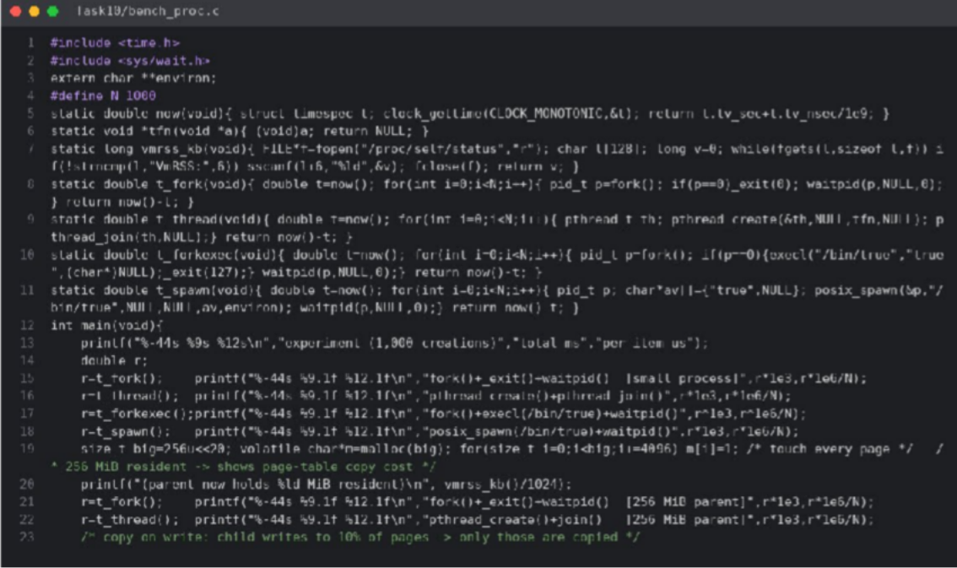
Figure 16: bench_proc.c – timing functions (Task10/bench_proc.c, lines 8–30)

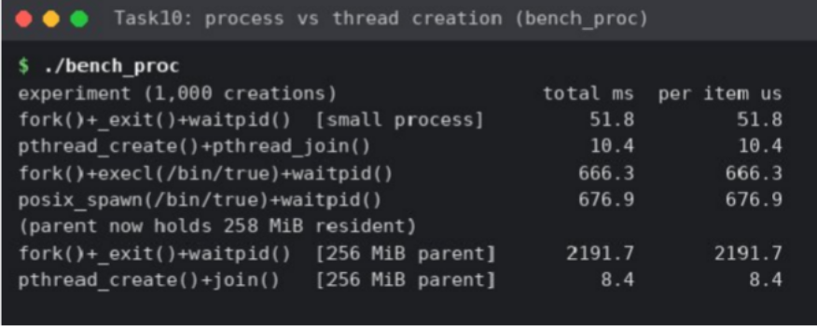
Figure 17: Measured creation time of 1,000 processes and 1,000 threads
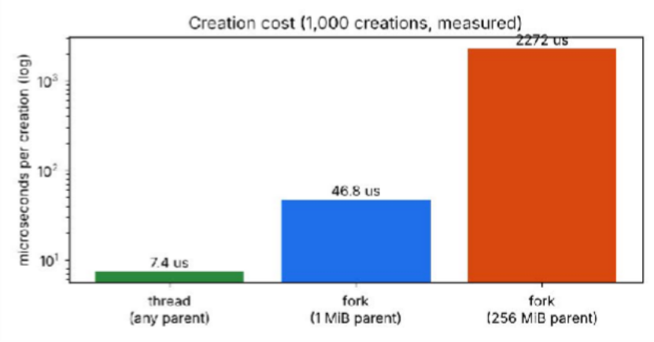
Figure 18: Creation cost per process/thread Table 20: Process vs thread creation – measured
Measurement | Result | Compared with expectation
1,000 × fork()+waitpid (small parent) | 46.8 ms (47 µs each) | As expected: tens of µs
1,000 × pthread_create+join | 6.8 ms (6.8 µs each) | ≈ 7× faster than a process – as expected, nothing to copy
1,000 × fork() with 256 MiB resident parent | 2,272 ms (2.3 ms each) | Larger than expected: page-table copy is proportional to mapped memory (48× slower than a small parent)
1,000 × thread with 256 MiB resident parent | 7.4 ms | Unchanged – threads share the same page tables
fork+exec vs posix_spawn | 631 ms vs 656 ms | Contradicts expectation that posix_spawn is faster; here the new program start-up dominates and parent is small

Do the measurements support the earlier judgements?
    - Supports Task 6/5: system calls are expensive per call → big buffers, library buffering and mmap help (up to 270× faster).
    - Supports Task 3: a system call is only ≈ 0.2 µs, so a microkernel's extra µs per request is small relative to a 10 ms alarm budget; the isolation benefit outweighs it.
    - Supports Task 7/11: threads are cheap but share memory (no isolation); processes cost more but isolate faults, so processes for commands, threads inside the imaging server.
    - Contradicts a simple expectation: posix_spawn gave no speed-up for a small parent; fork cost also depends on the parent's memory size, which I had not considered before measuring.

Alternative concept: threads instead of processes (explained by sharing)
A thread shares the address space (page tables), open files and heap with its siblings; it needs only its own stack, registers and thread-control block. A process copies the PCB, file table and page tables (copy-on-write for data). Hence creation time is O(1) for a thread and O(M) for a process (M = mapped memory); memory per extra thread
≈ stack only (≈ 8 KB–1 MB touched), per extra process ≥ private page tables and any written pages. The price is isolation: a wild pointer in one thread can corrupt every other thread.

TASK 11 – Recommend and Defend the Operating-System Plan (4 marks)
Table 21: Final operating-system plan

Environment | OS type / example | Structure | Key services | Protection | I/O method
Bedside monitor | Hard real-time RTOS (QNX  / FreeRTOS+MPU) | Microkernel (or small kernel with MPU) | Priority scheduler, timer, sensor + alarm drivers, authenticated net | Memory protection, signed firmware, watchdog | Interrupt-driven (+ timer sampling)
Nurse tablet | Handheld OS (Android Enterprise) | Hybrid (Linux kernel  + framework) | UI, Wi-Fi/TLS, power management | App sandbox, encryption, MDM, remote wipe | Interrupt-driven, DMA for camera/storage
Doctor workstation | Desktop OS (Linux/Windows) | Modular / hybrid | GUI, multi-user, printing, networking | Login, ACLs, disk encryption, MAC | Interrupt + DMA
Database server | Clustered SMP server OS (Linux), fail-over pair | Monolithic with modules | Journaling FS, TCP, quotas, audit | MAC (SELinux), ACLs, TLS,  encrypted storage | DMA, big RAM cache on SSD
Imaging server | SMP Linux, many cores | Monolithic with modules | Parallel scheduler, large files | Per-job users/cgroups | DMA from scanner, NVMe scratch
Partner link | Hardened Linux gateways, VPN/TLS | Monolithic with modules | Communication, authentication, auditing | Mutual TLS, firewall, audit | Interrupt + DMA (NIC)

Evidence from my own analysis and measurements
    - System-call cost ≈ 0.21 µs (Task 6) → a microkernel's µs-level IPC cost is acceptable against a 10 ms deadline, and its fault isolation protects the alarm.
    - A 64 KiB buffer made the backup copy 270–390× faster than 1-byte I/O (3.54 s → 0.009 s) → use large buffers in backup and database code.
    - Process creation 47 µs, thread 6.8 µs, fork with 256 MiB parent 2.3 ms → threads inside the imaging server, processes for isolation on the database/shell.
    - 500 MB image: 131 M interrupts (≈ 262 s CPU) vs 8,000 with DMA (16 ms) → DMA for MRI.
    - Availability 99.9 % → 99.9999 % with fail-over; Amdahl speed-up 9.1× on 16 CPUs (p = 0.95).

Limitations and risks
    - Several OS families increase administration, training and patching effort; mitigate with central device management and a standard Linux base for servers.
    - Microkernel IPC cost and RTOS licence cost; limited RTOS driver and application ecosystem.
    - Cluster complexity: split-brain, shared-storage failure, fail-over time of seconds (monitors keep alarming locally during it); software bugs are replicated to both nodes.
    - Tablets are lost or stolen – depends on MDM; hardware/measurement figures are from one test machine and typical industry values.

Does the plan suit a group of three hospitals?
Yes with additions: monitors, tablets and workstations scale by adding devices (each is an independent node, 500
* 1,500 monitors, 120 → 360 tablets); the database cluster moves to a geographically distributed replicated cluster (or one cluster per site with synchronous replication of shared records); the partner link becomes a distributed-system layer with a common identity provider, audit and encrypted replication. Limit: one cluster's write throughput (Amdahl) and WAN latency – cross-hospital reads are cached locally.

Alternative concept: all environments as VMs on two large servers
Table 22: Virtual machines on two large servers vs separate physical machines

Criterion | VMs on two servers | Separate physical machines (plan)
Monitor response time | Hypervisor scheduling adds jitter of ms under contention; also the monitors are physical devices that cannot be VMs – only server-side software can. Guaranteed 10 ms only with dedicated cores/real-time hypervisor | Monitor is a dedicated RTOS device: bounded ≈ 100 µs
Memory and CPU overhead | ≈ 2–10 % CPU, extra RAM for each guest OS kernel (≈ 0.5–1 GB × number of VMs) and hypervisor | None, but unused capacity in many small machines
Reliability | Host failure takes down all its VMs (large failure | Failure confined to one device; more machines →

 | domain); needs HA + live migration + shared storage; fewer machines to fail overall | more individual failures
Admin / cost | Fewer physical servers, snapshots, easy migration | More hardware to maintain

Decision: virtualise the server-side workloads (workstation VDI, partner gateway, test systems) to save hardware, but keep monitors, the database cluster and the imaging server on dedicated systems.

TASK 12 – Day-4 Design Challenge: Re-evaluate and Adapt the Design (8 marks)
Changed requirement: remote monitoring devices in patients' homes send readings over the Internet; patient records move to a cloud service shared with the partner hospitals. Decision: MODIFY – retain the in-hospital design, redesign the edges (home devices, records service and the link).

Impact Analysis (2 marks)
Table 23: What the new requirements change

Area | Affected? | Impact
OS types | Yes – two new types | Home device: embedded real-time OS (FreeRTOS/Zephyr) with TLS stack; Cloud: distributed system built from virtual machines/containers on a server OS. Hospital monitors, tablets, workstations, imaging server: unchanged.
Services | Yes | New: secure communication (TLS, MQTT/HTTPS), over-the-air update, device identity/provisioning, offline buffering when the link is down, remote logging; file system on the home device becomes minimal.
Protection & security | Yes – largest impact | Devices sit in untrusted homes: need secure boot, signed firmware, per-device certificates, encrypted storage; records leave the hospital → identity management, encryption in transit and at rest, per-patient access control and audit across organisations; the hospital LAN trust boundary disappears.
Response time | Yes | Network round-trip 20–100+ ms and unbounded jitter exceed the 10 ms alarm limit → the deadline cannot depend on the network.
Reliability | Yes | Internet outages; cloud region failure; dependence on a provider; must keep working offline.
Scale | Yes | Number of devices grows beyond the hospital; thousands of home devices; elasticity needed.

Evaluation of the Original Design (2 marks)
Table 24: Can the original plan support home devices and cloud records?

Aspect | Original design | Verdict
Response time | Hard-RT monitors with 10 ms local alarm; whole design assumed a short, owned LAN | Home alarm evaluated locally on the device still works (RTOS) – retain; but the central alarm path over the Internet (RTT 20–100 ms) cannot meet 10 ms → deadline must be local; cloud alert is a second, soft-real-time notification
Reliability | Fail-over cluster in one hospital; monitors on hospital power and network | Insufficient: Internet/power outages at home, single-site cluster, cloud dependence → need offline buffering, redundant notification path, multi-zone replication
Security | Perimeter-based: LAN trusted, partner link via VPN gateway | Insufficient: the perimeter model fails for home devices and cloud  * zero-trust (authenticate every device and request), encryption end-to-end, key management
Services / OS types | Monitor RTOS, handheld, desktop, clustered, SMP | Retain – each fits its job; add two environments
Scalability | Sized for 3 hospitals | Home devices multiply the connection count (e.g., +10,000 devices): needs elastic gateway tier

Conclusion of evaluation: the type/structure choices (RTOS microkernel, handheld, desktop, clustered server) remain valid; the network, security and records-sharing assumptions do not. So the answer is MODIFY, not RETAIN (insufficient security/availability) and not REDESIGN (the core still meets its requirements).

Adaptation or Redesign (2 marks)
Table 25: Revised plan

Component | Revised design
Home monitoring device | Embedded hard-real-time OS (FreeRTOS or Zephyr, microkernel-style isolation with MPU): local threshold

 | check and local buzzer within 10 ms; buffers readings in flash when offline; TLS 1.3 (mutual authentication, per-device certificate, secure boot, signed OTA updates); sleeps between samples for battery.
Home gateway / edge | Small Linux or RTOS gateway aggregates devices (e.g. Bluetooth/Zigbee) and connects to the hospital over VPN/TLS; local alarm if the cloud is unreachable.
Cloud records service | Distributed system on Linux VMs/containers behind a load balancer, replicated database across ≥ 2 availability zones (clustering idea from Task 2 extended), encryption at rest (customer-managed keys), mutual TLS, OAuth2/identity federation among the 3 hospitals, role- and patient-level access control, immutable audit log.
Hospital core | Unchanged: monitors, tablets, workstations, imaging server (SMP). Database cluster becomes the system of record or a synchronous replica of the cloud service; the partner link is replaced by cloud APIs plus a hardened gateway.
Protection / OS mechanisms | Kernel/user mode and memory protection on every node; containers/namespaces/cgroups and SELinux on cloud workers; hypervisor isolation between tenants; firmware signing at the edge.

Evidence-Based Defence (2 marks)
- Why not rely on the network for alarms: 10 ms deadline vs Internet RTT of 20–100 ms (typical). Tasks 1, 2 and 8 showed an alarm must be a bounded local interrupt-driven task; the RTOS design from Task 2 is therefore reused on the home device (RETAIN idea).
- Why a distributed/cloud records layer: Task 2 showed fail-over raises availability from 99.9 % to ≈ 99.9999 %; replication across zones extends this to the shared cloud service; a single hospital cluster would remain a single point of failure for 3 hospitals and the home users.
- Why microkernel/RTOS isolation matters more now: devices outside the hospital are physically accessible to attackers; my Task 3 evidence (fault-isolated drivers, 0.21 µs per system call, µs IPC) shows isolation costs microseconds only, while Task 8 showed that mode bits and memory protection stop one component from damaging another.
- Why not a full redesign: Task 10 and Task 11 evidence supports each existing choice (DMA for imaging, large buffers for backup, threads vs processes), and rebuilding them would add cost without benefit.
- Trade-offs accepted: more complexity (device fleet management, key management); recurring cloud cost; dependence on a provider and on data-protection law; added latency for non-critical data (accepted because only soft deadlines apply); mitigation by local alarms, offline buffering, multi-zone replication and strict auditing.
Final decision: MODIFY – keep the original OS-type plan for the hospital core, add an embedded RTOS tier for home devices with local alarm, and move shared records to a replicated, zero-trust cloud service.

APPENDIX A – GitHub submission (README and commit plan)
Repository name: CSA04-<RegisterNumber>-Assignment1 (public, or private with the faculty added as a collaborator). Folder per task: Task05, Task06, Task07, Task10 (code + outputs + screenshots) and a docs/ folder containing this Word report; Tasks 1–4, 8, 9, 11, 12 are theory and are in the report (add a short Task0X/README.md for each).
CSA04-<RegisterNumber>-Assignment1/
├── README.md
├── Task05/ sysread.c libio.c strace_*.txt screenshots/
├── Task06/ copy_file.c bench_copy.c measure.py run_time.sh results.json screenshots/
├── Task07/ shell.c shell_noflush.c zombie_orphan.c screenshots/
├── Task10/ bench_proc.c bench_proc_out.txt screenshots/
├── tools/ mystrace.c (ptrace-based strace clone used when strace is not installed)
└── docs/ Assignment1_Solution.docx
README.md must contain: name, register number, gcc 13.3.0, Ubuntu 24.04 LTS, compile command gcc -std=c11
-Wall -Wextra -pthread file.c -o name, how to run each program, and a one-line result per task (e.g. “Task 6: 10001 / 21 / 4 read() calls – matches expected output”).

Commands to run on your own machine and commit (one commit per task)
git init CSA04-<RegNo>-Assignment1 && cd CSA04-<RegNo>-Assignment1
git remote add origin https://github.com/<user>/CSA04-<RegNo>-Assignment1.git # Task 5
gcc -std=c11 -Wall -Wextra Task05/sysread.c -o Task05/sysread
strace ./Task05/sysread ; strace -c ./Task05/sysread # screenshot both git add Task05 && git commit -m "Task 5: system call walk-through + strace" # Task 6
gcc -std=c11 -Wall -Wextra -pthread Task06/copy_file.c -o Task06/copy_file
./Task06/copy_file ; strace -c ./Task06/copy_file # screenshot
git add Task06 && git commit -m "Task 6: copy_file TODO completed + measurements" # Task 7
gcc -std=c11 -Wall -Wextra Task07/shell.c -o Task07/shell && ./Task07/shell
git add Task07 && git commit -m "Task 7: fork/exec/waitpid shell + zombie/orphan" # Task 10
gcc -std=gnu11 -O2 -pthread Task10/bench_proc.c -o Task10/bench_proc && ./Task10/bench_proc git add Task10 && git commit -m "Task 10: process vs thread measurements"
git add docs README.md && git commit -m "Report and README" && git push -u origin main
Note: when you run the programs on your own computer, re-take the screenshots from your own terminal (and real strace) if the faculty requires it; your timings will differ from those in this report, but the call counts (10001/21/4, n/b) will be identical.

APPENDIX B – Source of the programs
Task05/sysread.c
#define _POSIX_C_SOURCE 200809L #include <fcntl.h>
#include <unistd.h>
/* Reads the first 32 bytes of a file with raw system calls and echoes them. */ int main(void) {
char buf[32];
int fd = open("/etc/hostname", O_RDONLY); /* openat() syscall */ ssize_t n = read(fd, buf, sizeof buf); /* read() syscall */
write(1, buf, (size_t)n); /* write() syscall */ close(fd); /* close() syscall */ return 0;
}
Task06/bench_copy.c

#define _POSIX_C_SOURCE 200809L #include <stdio.h>
#include <stdlib.h> #include <fcntl.h> #include <unistd.h> #include <sys/mman.h> #include <sys/stat.h> #include <string.h>
/* usage: bench_copy MODE src dst [bufsize] MODE = sys | stdio | mmap */ int main(int argc, char **argv) {
if (argc < 4) return 2;
const char *mode = argv[1], *src = argv[2], *dst = argv[3]; size_t b = argc > 4 ? (size_t)atol(argv[4]) : 4096;
if (!strcmp(mode, "sys")) { char *buf = malloc(b);
int in = open(src, O_RDONLY), out = open(dst, O_WRONLY|O_CREAT|O_TRUNC, 0644); ssize_t n;
while ((n = read(in, buf, b)) > 0) { if (write(out, buf, (size_t)n) != n) return 1; } close(in); close(out); free(buf);
} else if (!strcmp(mode, "stdio")) {
FILE *in = fopen(src, "rb"), *out = fopen(dst, "wb"); char *buf = malloc(b); size_t n;
while ((n = fread(buf, 1, b, in)) > 0) fwrite(buf, 1, n, out); fclose(in); fclose(out); free(buf);
} else { /* mmap: map input, one write() of whole file */
int in = open(src, O_RDONLY), out = open(dst, O_WRONLY|O_CREAT|O_TRUNC, 0644); struct stat st; fstat(in, &st);
char *p = mmap(NULL, (size_t)st.st_size, PROT_READ, MAP_PRIVATE, in, 0);
size_t off = 0; while (off < (size_t)st.st_size) { ssize_t w = write(out, p+off, (size_t)st.st_size-off); if (w<=0) return 1; off += (size_t)w; } munmap(p, (size_t)st.st_size); close(in); close(out);
}
return 0;
}
Task07/zombie_orphan.c
#define _DEFAULT_SOURCE #include <stdio.h> #include <stdlib.h> #include <unistd.h> #include <sys/wait.h>
/* Demonstrates a zombie (child exited, parent has not wait()ed) and an orphan. */ int main(void) {
pid_t z = fork();
if (z == 0) _exit(0); /* child dies at once */
sleep(1); /* parent does NOT wait yet */
char cmd[64]; snprintf(cmd, sizeof cmd, "ps -o pid,ppid,stat,comm -p %d", (int)z); printf("--- zombie child %d (state Z = defunct) ---\n", (int)z); fflush(stdout); system(cmd);
waitpid(z, NULL, 0); /* reap: zombie disappears */ printf("--- after waitpid() the entry is gone ---\n"); fflush(stdout); system(cmd);
pid_t o = fork();
if (o == 0) { /* orphan: parent exits first */ printf("orphan: parent before = %d\n", (int)getppid()); fflush(stdout); sleep(2);
printf("orphan: parent after = %d (adopted by init/subreaper)\n", (int)getppid()); fflush(stdout);
_exit(0);
}
usleep(300000);
return 0; /* parent exits, child orphaned */
}
Task10/bench_proc.c
#define _GNU_SOURCE

#include <stdio.h> #include <stdlib.h> #include <string.h> #include <unistd.h> #include <pthread.h> #include <spawn.h> #include <time.h> #include <sys/wait.h> extern char **environ; #define N 1000
static double now(void){ struct timespec t; clock_gettime(CLOCK_MONOTONIC,&t); return t.tv_sec+t.tv_nsec/1e9; } static void *tfn(void *a){ (void)a; return NULL; }
static long vmrss_kb(void){ FILE*f=fopen("/proc/self/status","r"); char l[128]; long v=0; while(fgets(l,sizeof l,f)) if(!strncmp(l,"VmRSS:",6)) sscanf(l+6,"%ld",&v); fclose(f); return v; }
static double t_fork(void){ double t=now(); for(int i=0;i<N;i++){ pid_t p=fork(); if(p==0)_exit(0); waitpid(p,NULL,0);} return now()-t; } static double t_thread(void){ double t=now(); for(int i=0;i<N;i++){ pthread_t th; pthread_create(&th,NULL,tfn,NULL); pthread_join(th,NULL);} return now()-t; }
static double t_forkexec(void){ double t=now(); for(int i=0;i<N;i++){ pid_t p=fork(); if(p==0){execl("/bin/true","true",(char*)NULL);_exit(127);} waitpid(p,NULL,0);} return now()-t; } static double t_spawn(void){ double t=now(); for(int i=0;i<N;i++){ pid_t p; char*av[]={"true",NULL}; posix_spawn(&p,"/bin/true",NULL,NULL,av,environ); waitpid(p,NULL,0);} return now()-t; }
int main(void){
printf("%-44s %9s %12s\n","experiment (1,000 creations)","total ms","per item us"); double r;
r=t_fork(); printf("%-44s %9.1f %12.1f\n","fork()+_exit()+waitpid() [small process]",r*1e3,r*1e6/N); r=t_thread(); printf("%-44s %9.1f %12.1f\n","pthread_create()+pthread_join()",r*1e3,r*1e6/N); r=t_forkexec();printf("%-44s %9.1f %12.1f\n","fork()+execl(/bin/true)+waitpid()",r*1e3,r*1e6/N); r=t_spawn(); printf("%-44s %9.1f %12.1f\n","posix_spawn(/bin/true)+waitpid()",r*1e3,r*1e6/N);
size_t big=256u<<20; volatile char*m=malloc(big); for(size_t i=0;i<big;i+=4096) m[i]=1; /* touch every page */ /* 256 MiB resident -> shows page-table copy cost */
printf("(parent now holds %ld MiB resident)\n", vmrss_kb()/1024);
r=t_fork(); printf("%-44s %9.1f %12.1f\n","fork()+_exit()+waitpid() [256 MiB parent]",r*1e3,r*1e6/N); r=t_thread(); printf("%-44s %9.1f %12.1f\n","pthread_create()+join() [256 MiB parent]",r*1e3,r*1e6/N);
/* copy-on-write: child writes to 10% of pages -> only those are copied */ return 0;
}

